Container With Most Water:

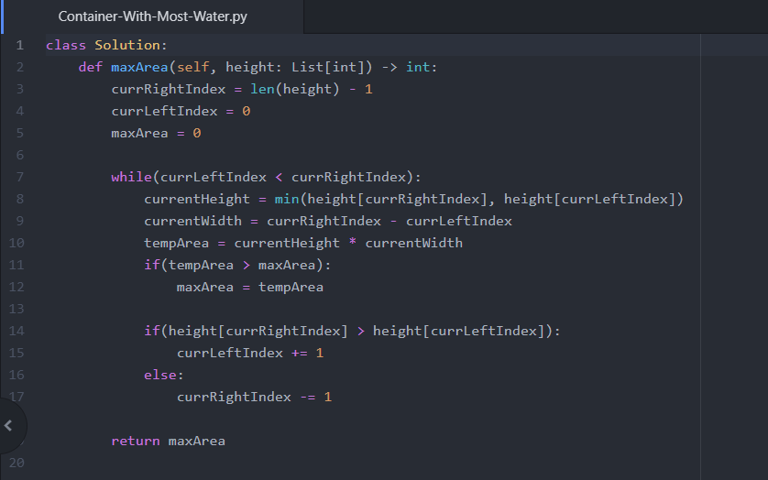

Discussed with: Tanner Bangerter

Flower Planting With No Adjacent: 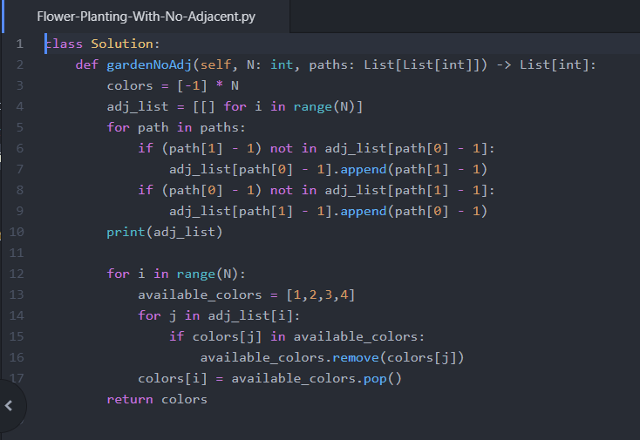

Discussed with: Tanner Bangerter

Nth Tribonacci: 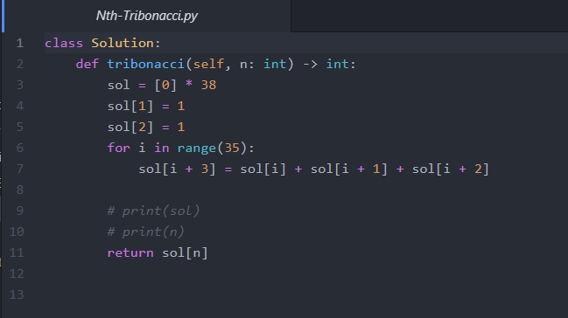

Discussed with: Tanner Bangerter

Queue Reconstruction By Height: 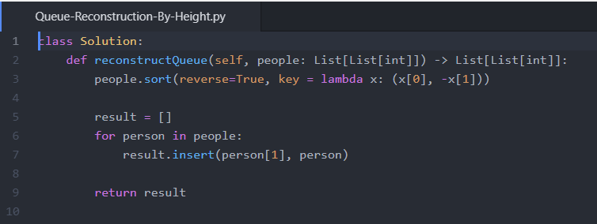

Triangle: 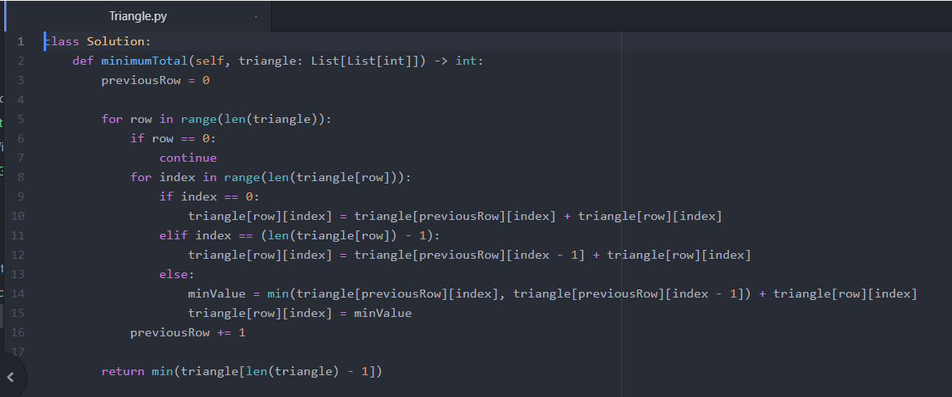

Discussed with: Tanner Bangerter

Two Sum: 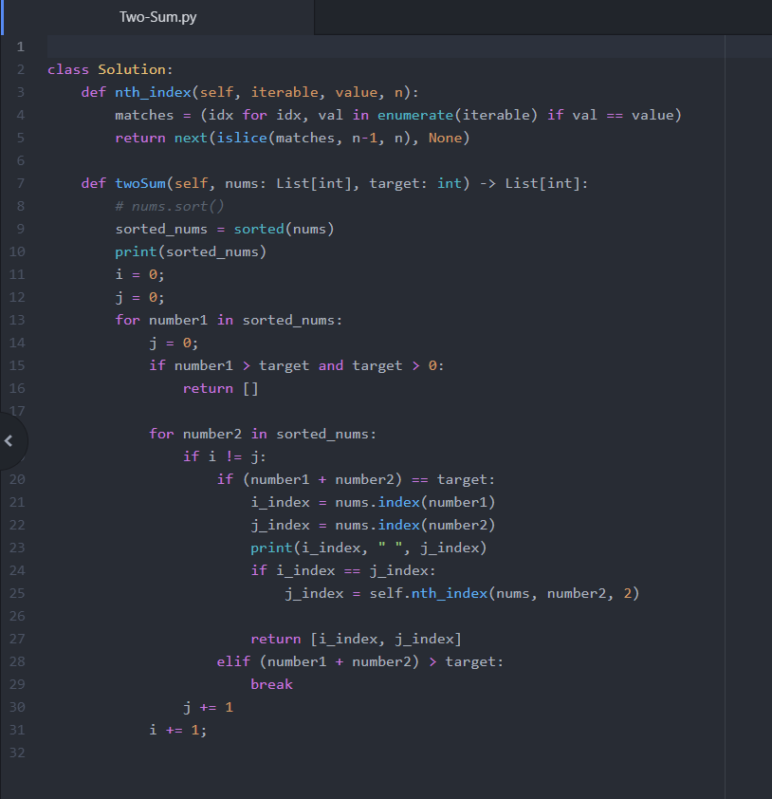

Discussed with: Tanner Bangerter